2016 Pack 24 Pinewood Derby Survival Guide

Your scout can use this guide to sketch out his design ideas.
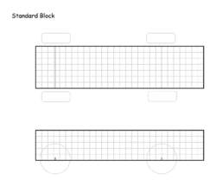
The Pack 24 Pinewood Derby begins at 1pm on Saturday, January 30, 2016 (cars must be checked in before noon).

We race by rank starting with Tigers and ending with Webelos II. We award design categories to each rank, the prizes are:
•Funniest •Most Creative •Scout-Inspired •Fastest-Looking •Coolest
The fastest three cars in each rank win a den trophy. The top 16 fastest cars go to the championship round, and the five fastest cars will win a pack trophy

TIPS
- Make sure your car meets all the limits on weight, and dimensions as specified in the rules we will post on the website.
- All cars are checked at registration the morning of the derby to make sure they weigh less than 5.0 ounces and fit inside a box that confirms max width and height.
- Make sure your scout doesn’t have weight on the bottom of his car, as these can be caught on the track
- Display the car number on the back of your scout’s car using the numbers provided in the kit. Your scout’s assigned number is on the label printed on the kit.
- Use only the parts supplied in the pinewood kit supplied by the pack. Axles benefit from a good polishing to remove stamp marks and other imperfections that can really slow down the cars.

