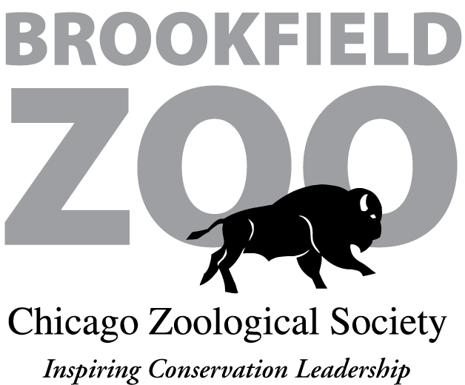

Parental Consent Form

I hereby give my child, ________________, permission to participate in an overnight visit to Brookfield Zoo on ___________________, 20___, which will be conducted through my child’s participation in ____________________ (the “group”). I understand and agree that the following terms and conditions established by the Chicago Zoological Society (which operates Brookfield Zoo) will apply to my child’s participation in this overnight program:

- The chaperone(s) provided by the group is responsible to make sure all group members are well behaved and courteous, comply with instructions given by the Chicago Zoological Society (“the Society”) and the group leader, and are respectful of Society property, staff, and other guests. The misbehavior of any participant could result in the removal of the entire group from the zoo, as well as the offending guest.

- The group will be assigned a Chicago Zoological Society Staff Leader, and all guests must comply with the Staff Leader’s instructions at all times. If your child or any other child does not comply, s/he (and possibly the entire group) will be asked to leave the zoo premises immediately.

- The Society provides all food and beverages during overnight stays. Guests may not bring any food, snacks, or beverages into the zoo. If your child has special dietary needs, you must contact the Camp and Overnights Supervisor at the Hamill Family Play Zoo at 708-688-8277 no later than 5 days before the scheduled visit so that appropriate arrangements can be made.

- Fences and walls around animal exhibits are for the safety of the public and the animals. Climbing on or over any enclosure is strictly prohibited.

- Zoo animals are especially sensitive to flashes of light. Using cameras with a flash in or around any of the exhibits is prohibited at all times. Limited use of flashlights is allowed and will be closely managed and supervised by the Staff Leader. Guests may use flashlights only when they are told they may do so by the Staff Leader.

- Alcohol is strictly prohibited in Brookfield Zoo, including the parking lot. If a member of the group violates this rule, the entire group will be removed from the zoo.

- Chaperones are solely responsible for the supervision, health, and well-being of all members of the group. Chaperones are required to stay with their group and control the group members’ behavior throughout the entire overnight. If your child asks or is asked to leave the zoo before the end of the overnight for any reason, the chaperone will be responsible for making arrangements for him/her to be picked up and transported to his/her home.

- Chaperones are responsible for being aware of and attending to any personal medical or emotional needs of all members of the group. If your child has any such needs, you should contact a group representative. The Society will provide reasonable accommodations to persons with disabilities as required by applicable law. If your child needs any accommodation, you should contact the Camp and Overnights Supervisor at the Hamill Family Play Zoo at 708-688-8277 no later than five days prior to his/her scheduled visit so that appropriate arrangements can be made.

- Because of the nature of its operations, the Chicago Zoological Society reserves the right to terminate an overnight visit at any time in its sole discretion. If termination is due to the misconduct or other behavior of any member of the group, no fees or other costs will be reimbursed to any member of the group.

Signed and Agreed ____________________________________________________________

Printed Name _______________________________________________________________

Parent/Guardian For: _________________________________________________________
(Please Print)

Date: _________________, 20____

/tmp/in/input.doc

